[ PYTHON ASSIGNMENT ]

NAME :- SHUBHAM PRAJAPATI

COURSE :- BTECH ( ELECTRICAL ENGINEERING )

SUBJECT :- PROGRAMMING FUNDAMENTALS FOR ELECTRONICS ENGINEERS

ADMISSION NUMBER :- 25SECE1050013

1.Write a program that accepts user input ( name and age ) , prints a formatted message , and displays that data type of each input .
#code
name = input("Enter your name: ")
age = int(input("Enter your age: "))
print(f"\nHello {name}, you are {age} years old.")
print("\nData type of name:", type(name))
print("Data type of age:", type(age))

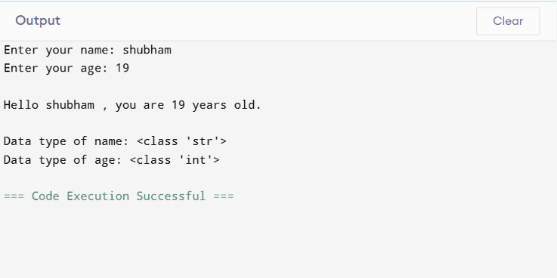

2.Develop a Python program that takes a number as input and determines whether it is positive , negative , or zero .
#code
num = float(input("Enter a number: "))
if num > 0:
print("The number is Positive")
elif num < 0:
print("The number is Negative")
else:
print("The number is Zero")

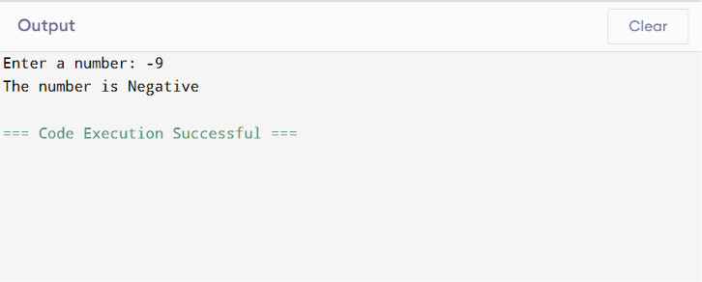
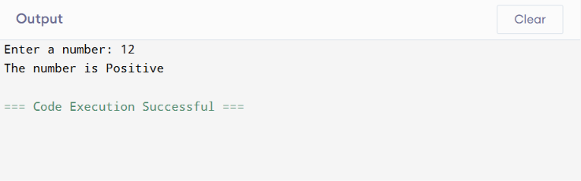
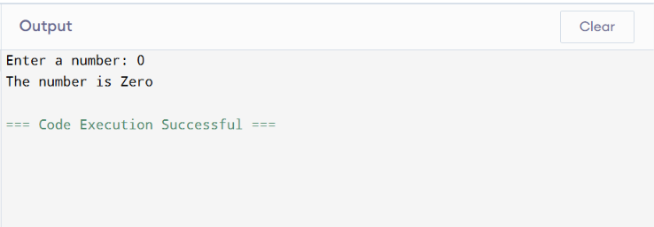

3.Create a Python program to calculate the sum of first N natural numbers using a loop .
#code
N = int(input("Enter a number: "))
total = 0
for i in range(1, N + 1):
total += i
print("Sum of first", N, "natural numbers is:", total)
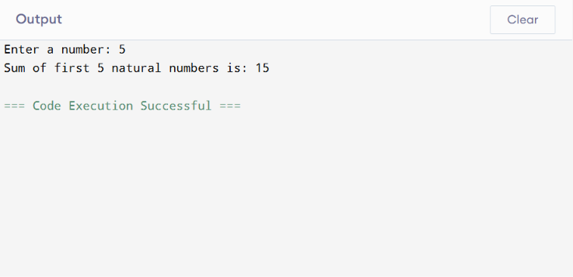
4. Write a python program demonstrating the use of arithmetic , comparison , and local operators .
#code
a = int(input("Enter first number: "))
b = int(input("Enter second number: "))
print("\nArithmetic Operators")
print("Addition:", a + b)
print("Subtraction:", a - b)
print("Multiplication:", a * b)
print("Division:", a / b)
print("\nComparison Operators")
print("a == b :", a == b)
print("a > b :", a > b)
print("a < b :", a < b)
print("a != b :", a != b)
print("\nLogical Operators")
print("(a > 0 and b > 0):", a > 0 and b > 0)
print("(a > 0 or b > 0):", a > 0 or b > 0)
print("not(a > b):", not(a > b))
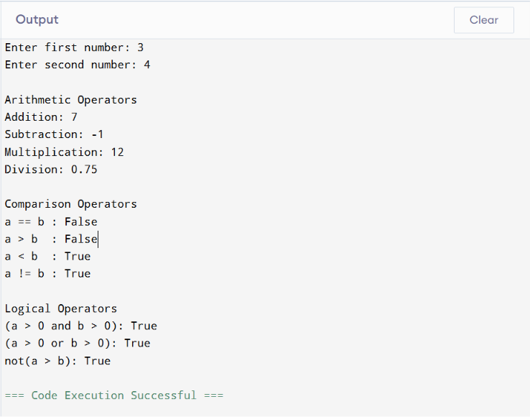

5. Write a Python program that reads a list of numbers from the user , finds the maximum , minimum , and sum , and sort the list .
#code
numbers = list(map(int, input("Enter numbers separated by space: ").split()))
maximum = max(numbers)
minimum = min(numbers)
total = sum(numbers)
numbers.sort()
print("\nMaximum number:", maximum)
print("Minimum number:", minimum)
print("Sum of numbers:", total)
print("Sorted list:", numbers)
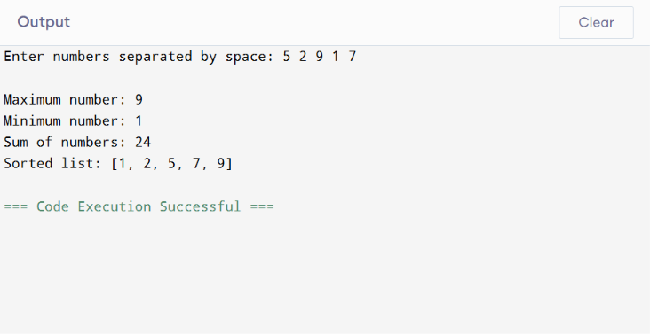

6. Develop a Python program that accepts a string and performs multiple operations such as counting vowels, reversing the string, and checking for palindrome.
#code
text = input("Enter a string: ")
vowels = "aeiouAEIOU"
count = 0
for char in text:
if char in vowels:
count += 1
reversed_text = text[::-1]
if text.lower() == reversed_text.lower():
palindrome = True
else:
palindrome = False
print("\n--- String Operations ---")
print("Original String :", text)
print("Number of vowels:", count)
print("Reversed String :", reversed_text)
if palindrome:
print("The string is a Palindrome.")
else:
print("The string is NOT a Palindrome.")

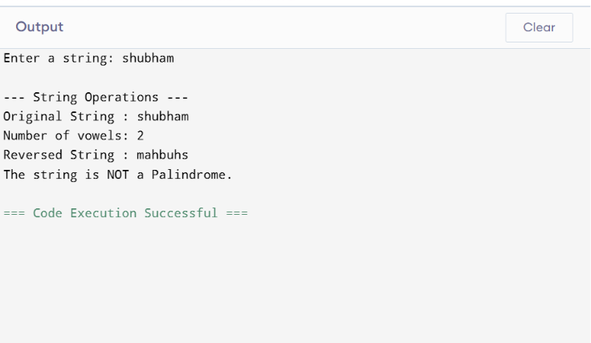
7. Write a Python program using functions to perform operations like factorial and Fibonacci sequence.
#code
def factorial(n):
fact = 1
for i in range(1, n + 1):
fact *= i
return fact
def fibonacci(n):
a, b = 0, 1
print("Fibonacci Sequence:")
for i in range(n):
print(a, end=" ")
a, b = b, a + b
num = int(input("Enter a number: "))
print("\nFactorial of", num, "is:", factorial(num
print()
fibonacci(num)

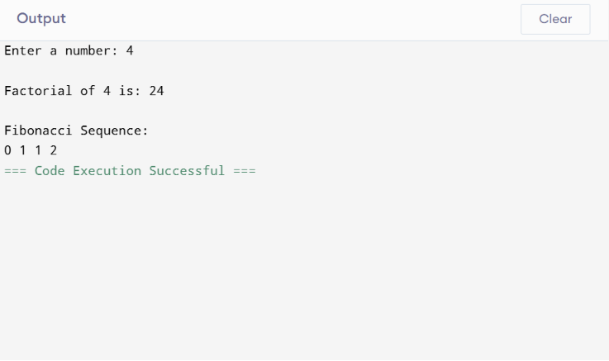

8. Create a program that uses dictionaries to store student names and marks, then finds and displays the highest and lowest scorer.
#code
students = {}
n = int(input("Enter number of students: "))
for i in range(n):
name = input("Enter student name: ")
marks = int(input("Enter marks: "))
students[name] = marks
highest_student = max(students, key=students.get)
lowest_student = min(students, key=students.get)
print("\nStudent Records:")
for name, marks in students.items():
print(name, ":", marks)
print("\nHighest Scorer:")
print(highest_student, "-", students[highest_student])
print("\nLowest Scorer:")
print(lowest_student, "-", students[lowest_student])

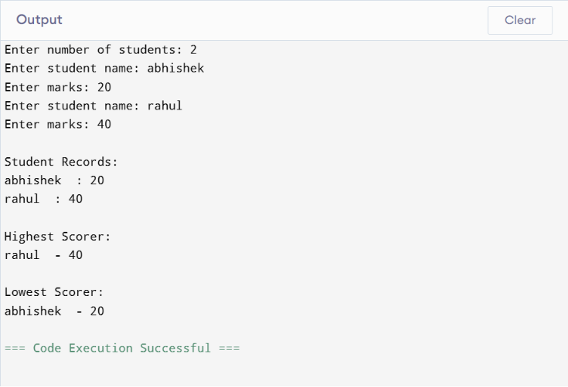

9. Write a Python program that reads data from a file, processes the content (such as counting words and lines), and handles possible errors using exception handling.
#code
try:
file_name = input("Enter the file name: ")
file = open(file_name, "r")
content = file.read()
lines = content.split('\n')
line_count = len(lines)
words = content.split()
word_count = len(words)
print("\nFile Content:\n")
print(content)
print("\nTotal Lines:", line_count)
print("Total Words:", word_count)
file.close()
except FileNotFoundError:
print("Error: File does not exist.")
except Exception as e:
print("An error occurred:", e) 